

DIGITAL MARKETING

**PROJECT REPORT**

**PROJECT TITLE**: *HOW TO SUBMIT YOUR WEBSITE’S SITEMAP TO GOOGLE SEARCH CONSOLE*

# Submitted By:

1. AMIRDHA T au613020104004

2. KAVIYA V au613020104036

3. MOHANAVALLI M au613020104044

4. MONISA S au613020104045

**BE – Computer Science and Engineering**

**Vivekanandha College of Technology for Women**

**Namakkal - 637205**

**CREATE A BLOG AND PUBLISH YOUR POST:**

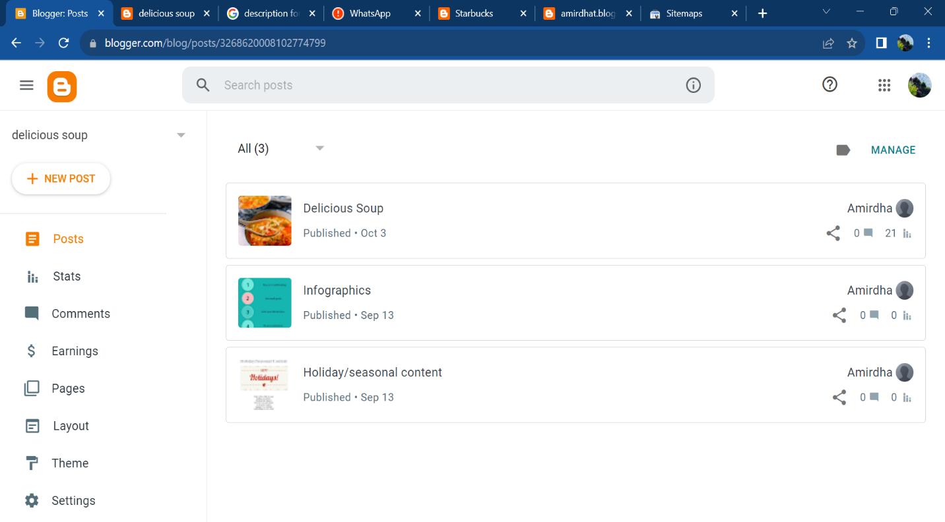**Step 1:** Publish a post:

**Step 2**: Go to settings:

i) Describe your post details:

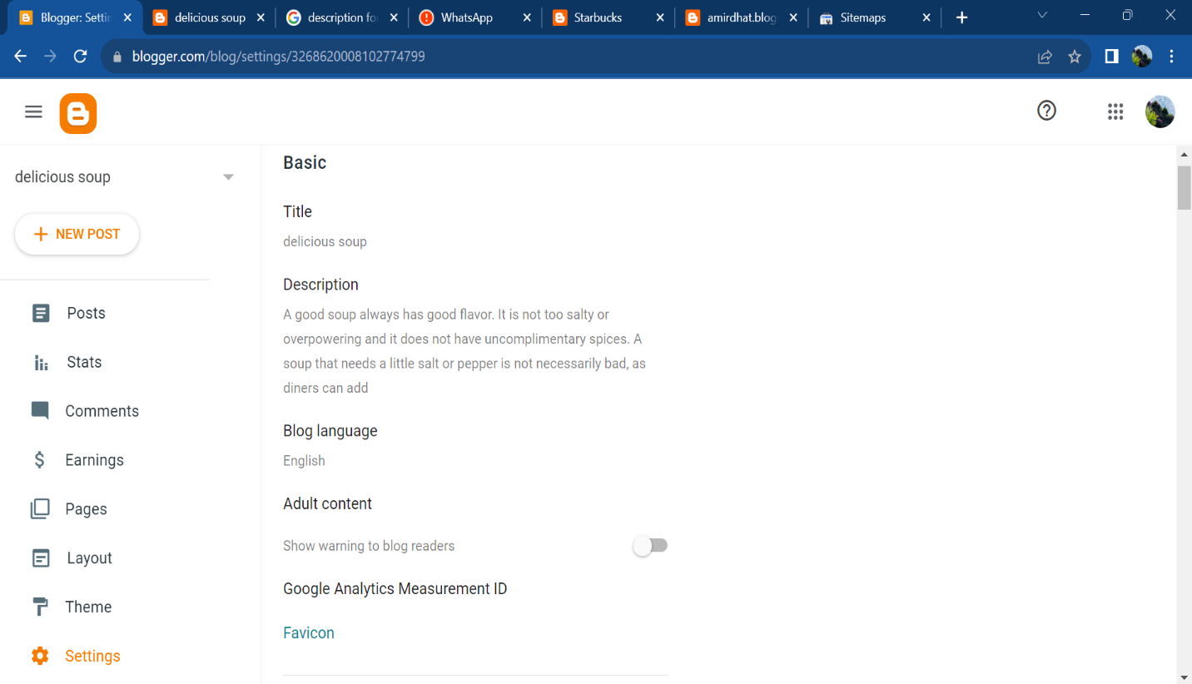

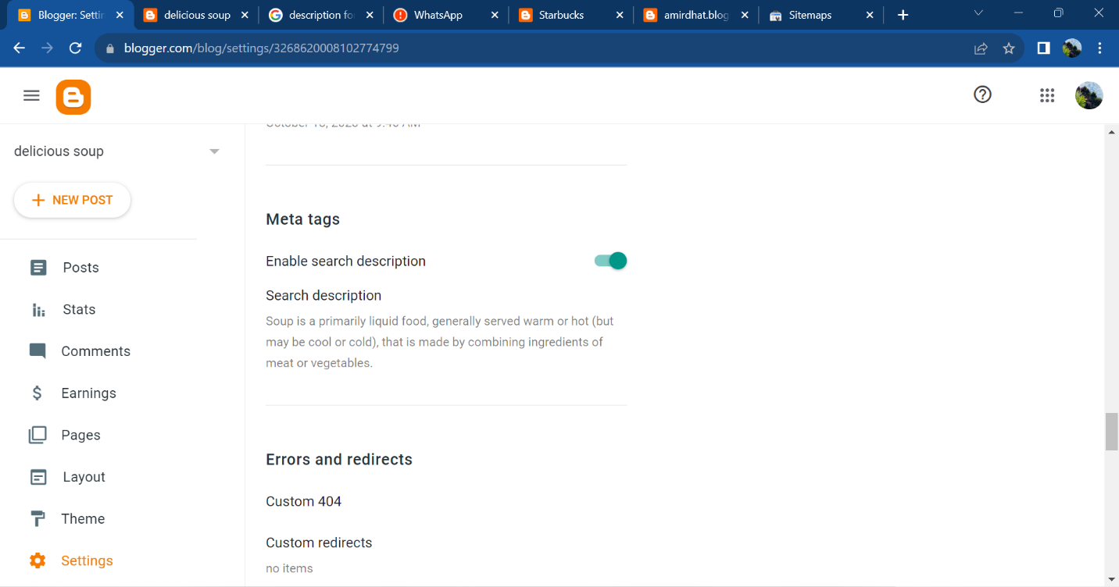ii) Scroll down and click enable search description:

iii) Copy your blog URL:

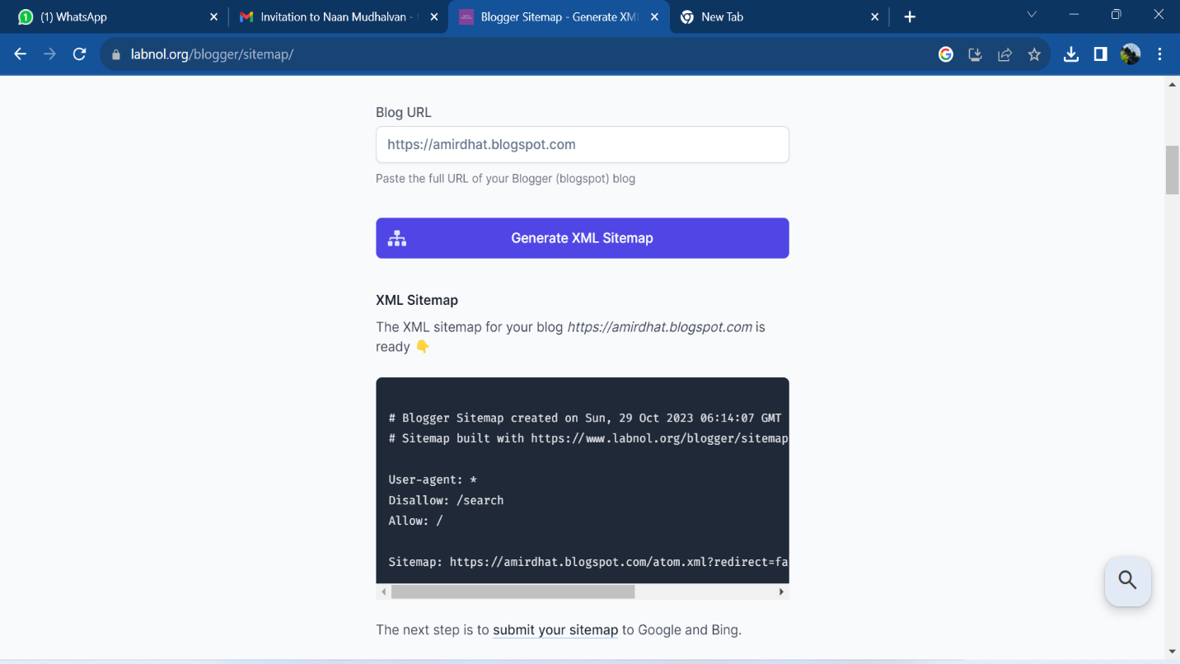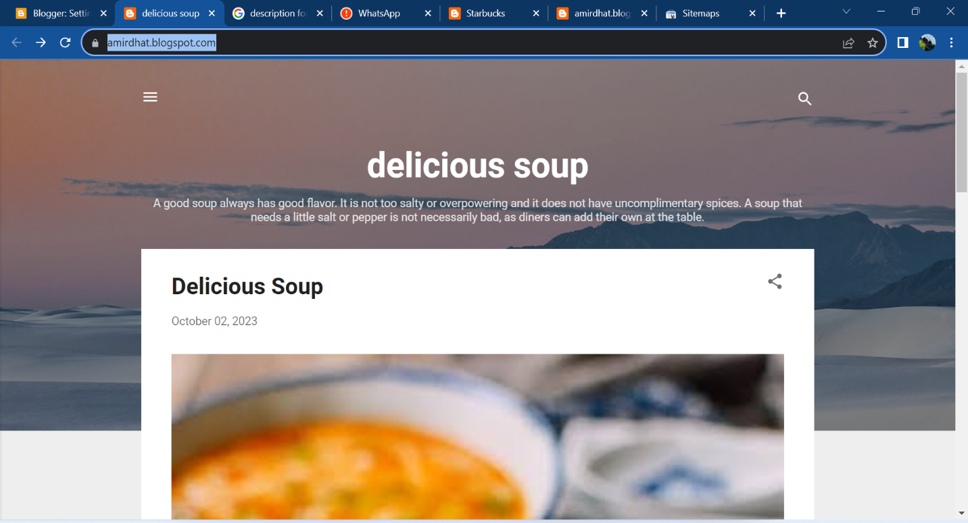iv) Generate your XML sitemap:

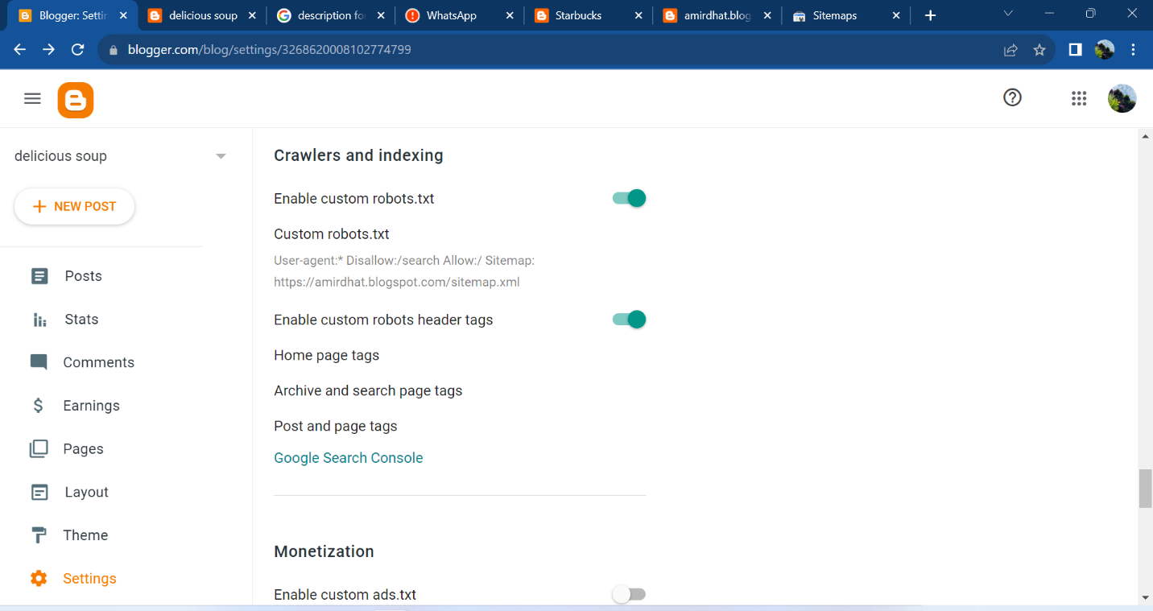v) Enable custom robots.txt:

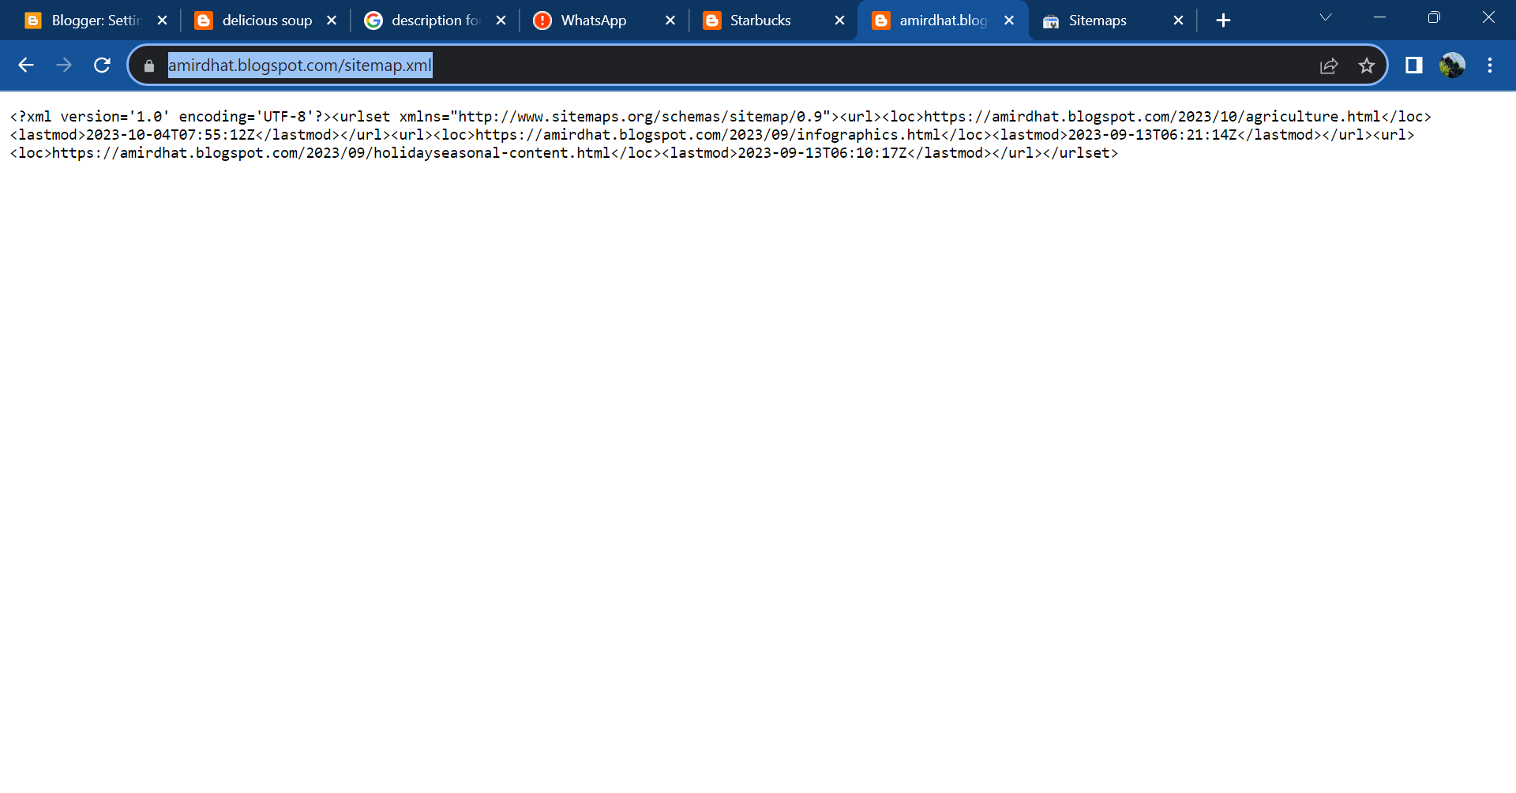vi) Create sitemap.xml for your blog:

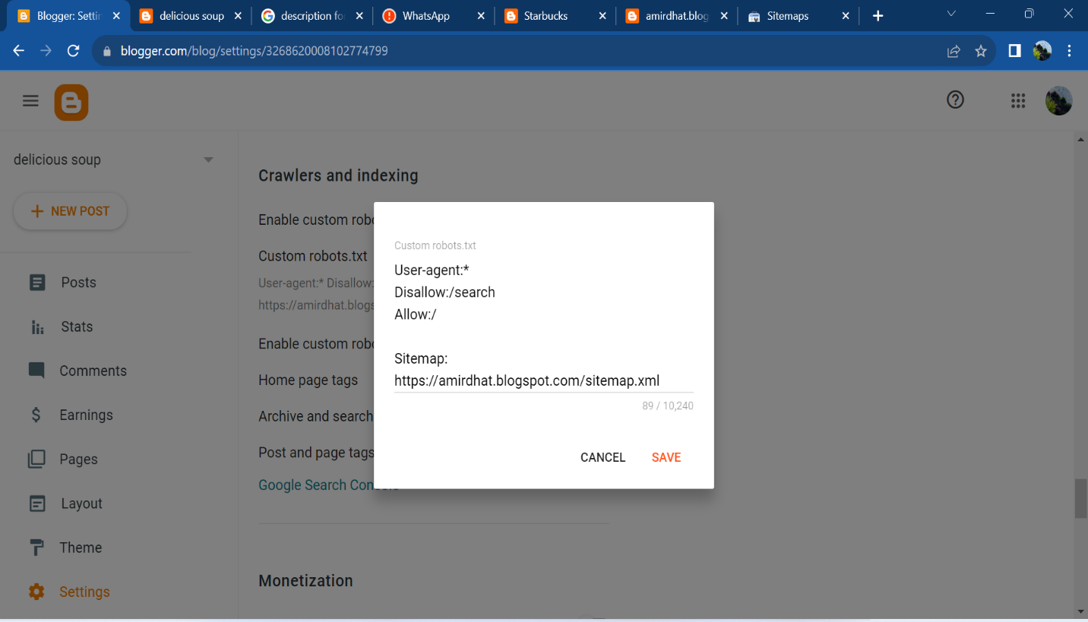vii) Paste your generated XML sitemap in custom robots.txt:

**SUBMIT YOUR WEBSITE’S SITEMAP TO GOOGLE SEARCH CONSOLE:**

**Step 1:** Navigate to Google Search Console:

https://www.google.com/search?q=google+search+console&rlz=1C 1ONGR_enIN1042IN1042&oq=&gs_lcrp=EgZjaHJvbWUqCQgAECMYJxjqAjIJCAAQI xgnGOoCMgkIARAjGCcY6gIyCQgCECMYJxjqAjIJCAMQIxgnGOoCMgkIBBAjGCcY6gIyCQgFECMYJxjqAjIJCAYQIxgnGOoCMgkIBxAjGCcY6gLSAQoxNDIxMjBqMGo3 qAIIsAIB&sourceid=chrome&ie=UTF-8

**Step 2:** Search and Select Google Search Console:

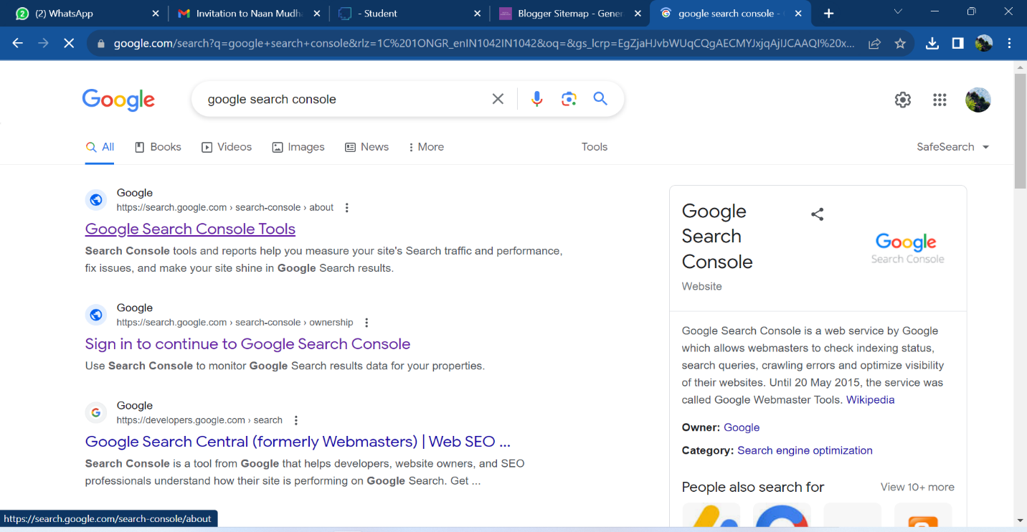

**Step 3:** Click “Start Now”:

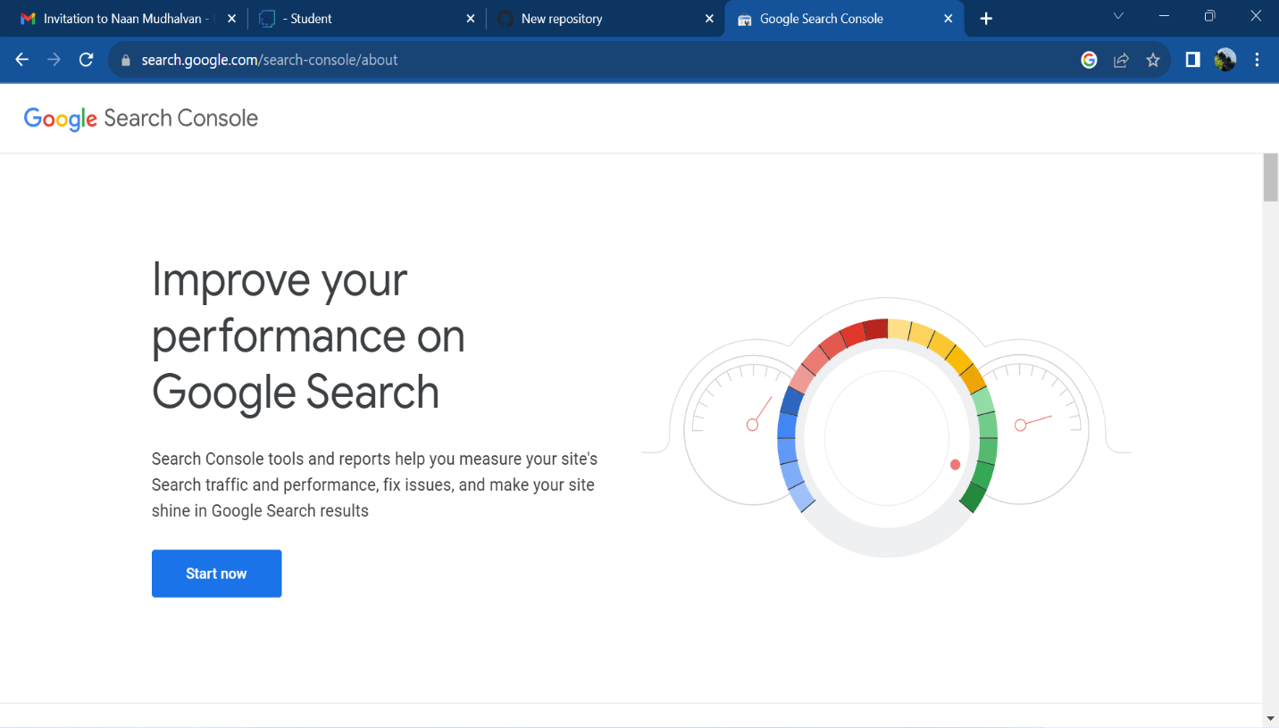

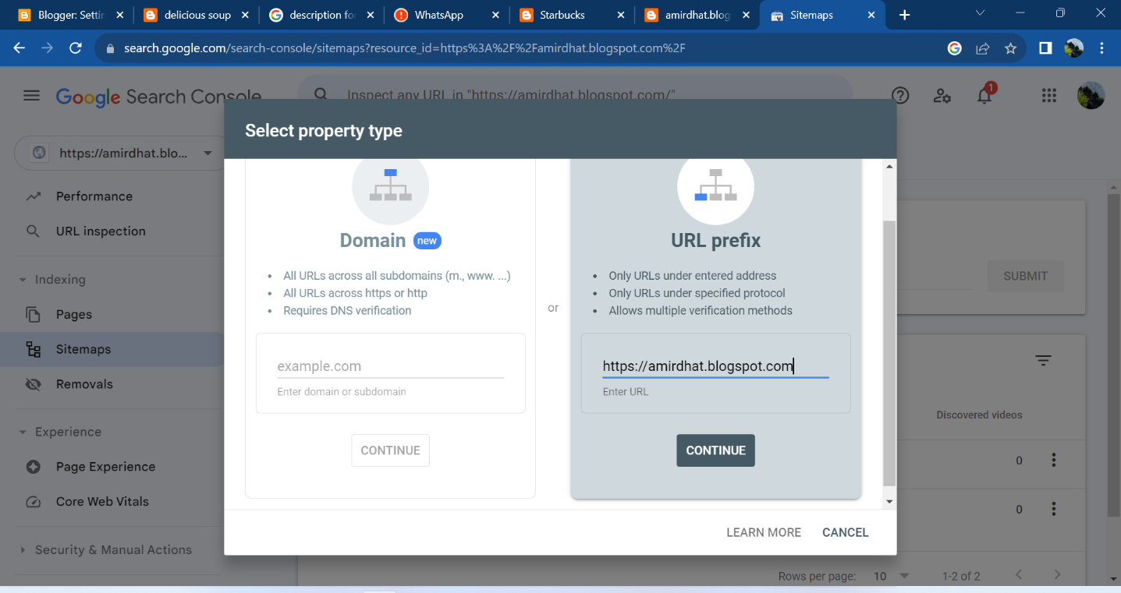**Step 4:** Enter your website URL:

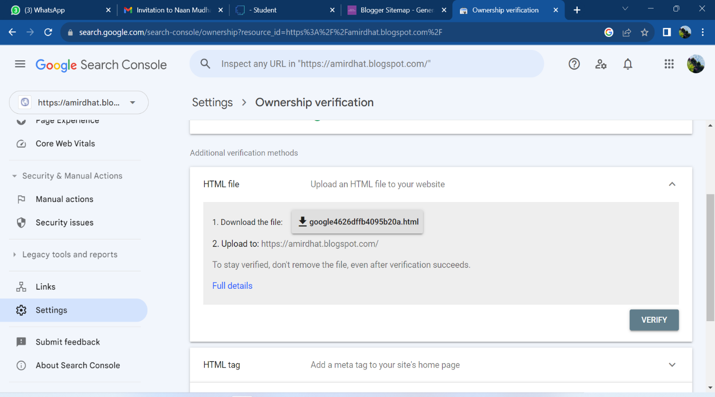**Step 5:** Verify your Ownership:

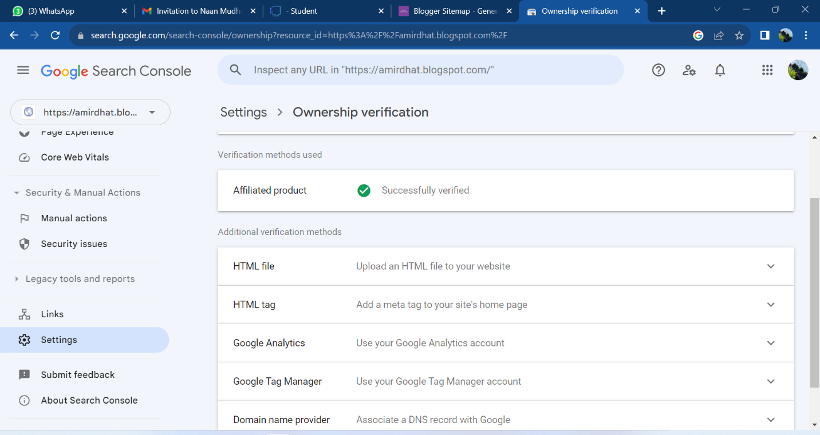**Step 6:** Verify using google analytics:

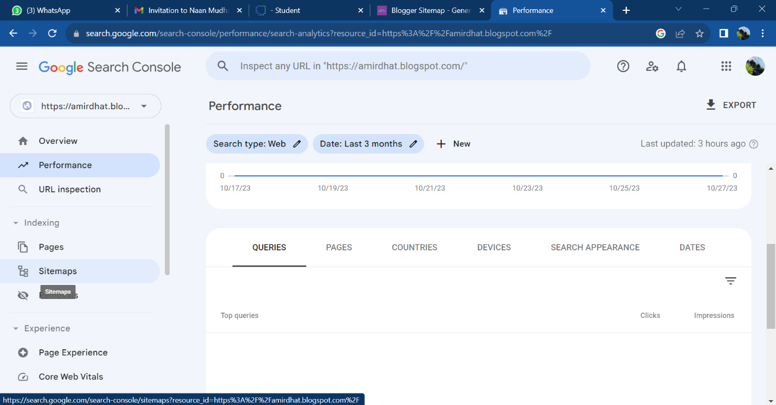**Step 7:** Go to Sitemap:

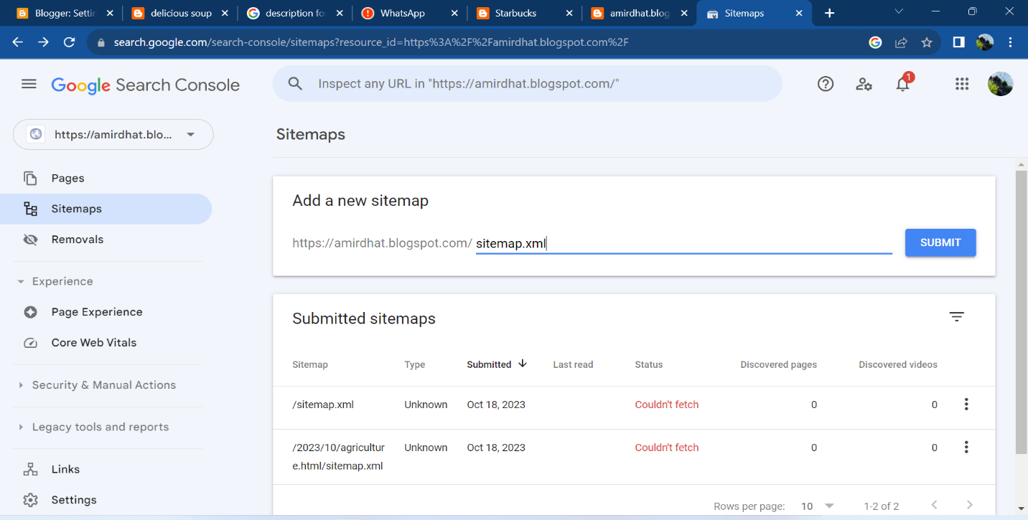**Step 8:** Click this text field and type sitemap.xml and click submit button:

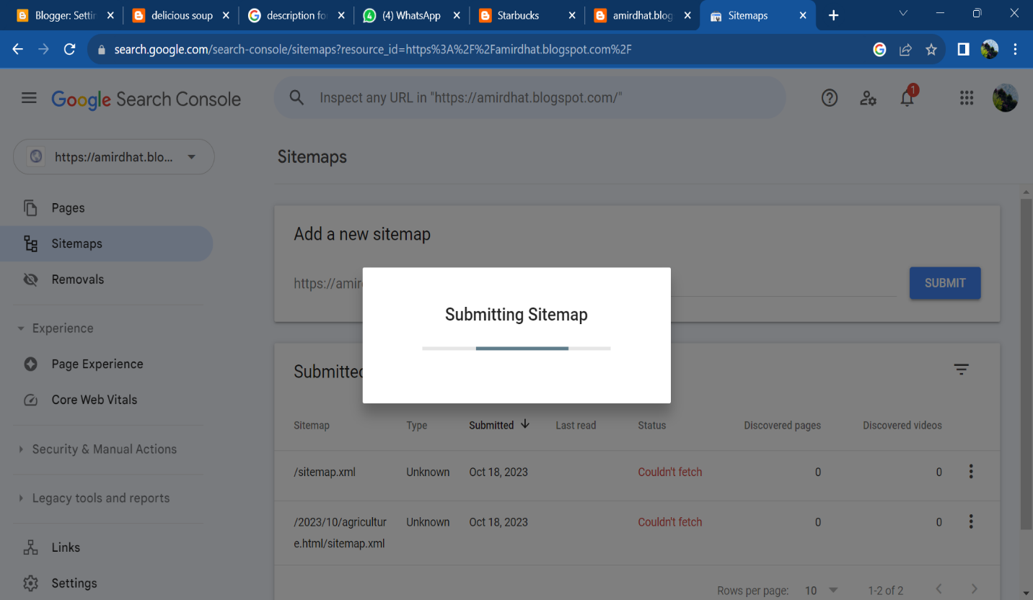**Step 9:** After submitting you will see a confirmation message - sitemap submitted successfully and select the newly updated sitemap below:

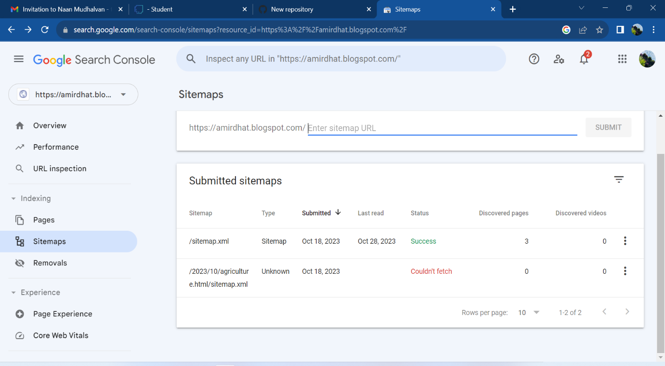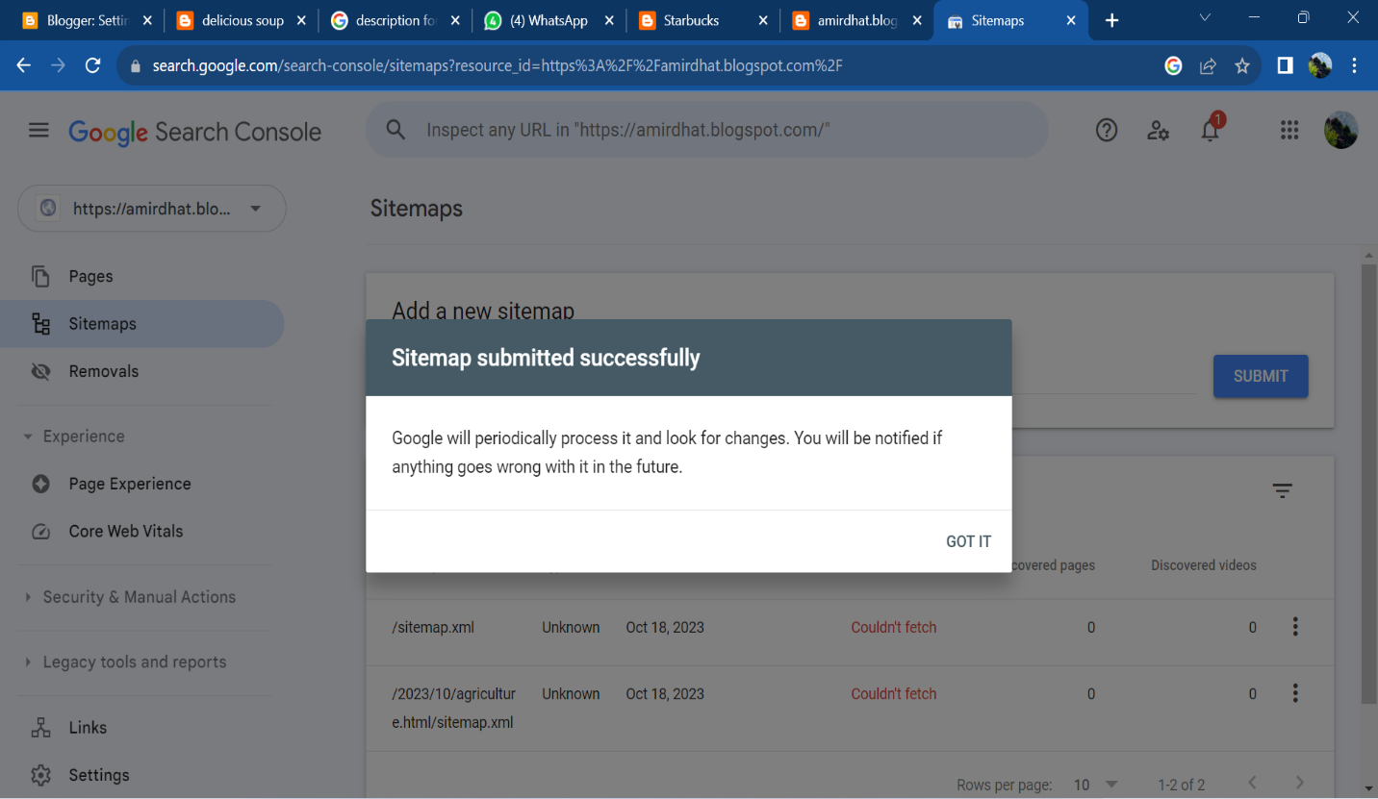

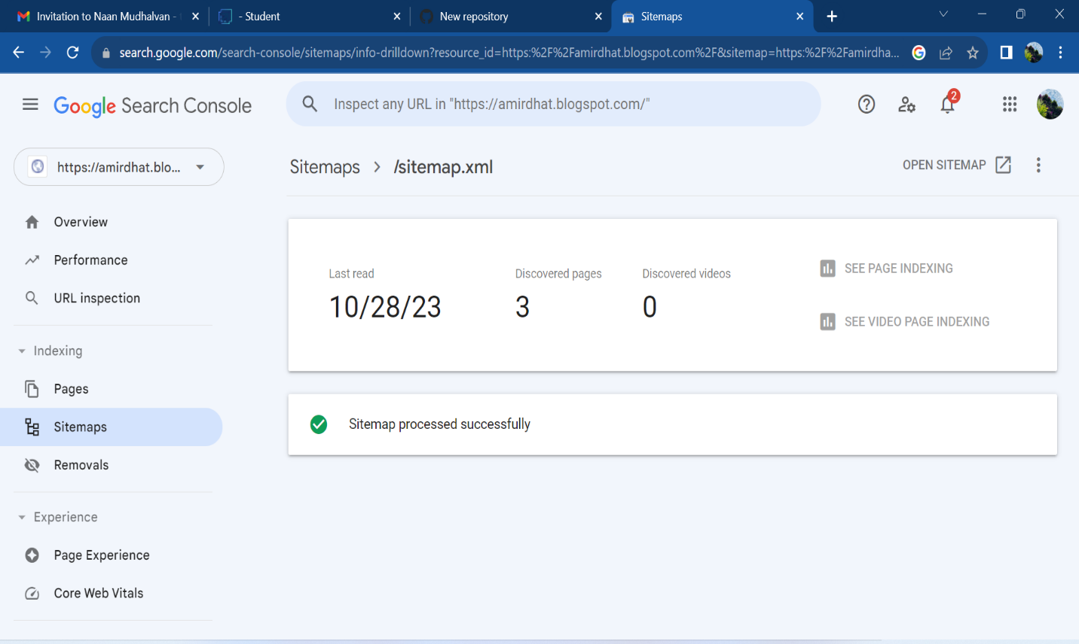 **Step 10:** Here you can see how many pages were indexed. If you see a “Couldn’t fetch” or Has errors” status, you will need to follow the report's suggestions on how to fix the issues.

**SUBMITTED SITEMAP SCREENSHOTS OF THE TEAM MEMBERS:**

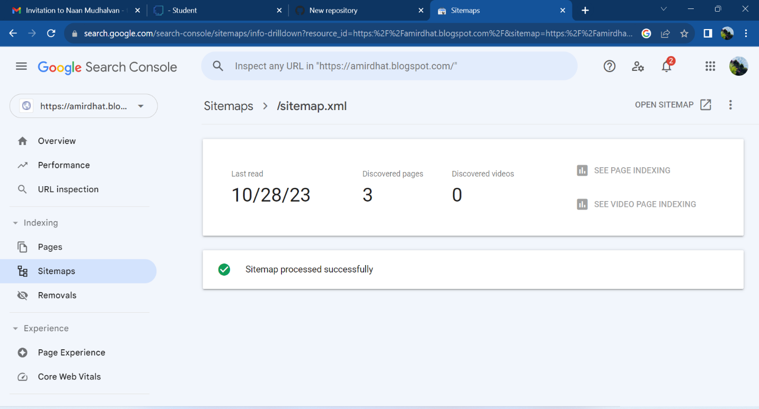T. Amirdha – 613020104004

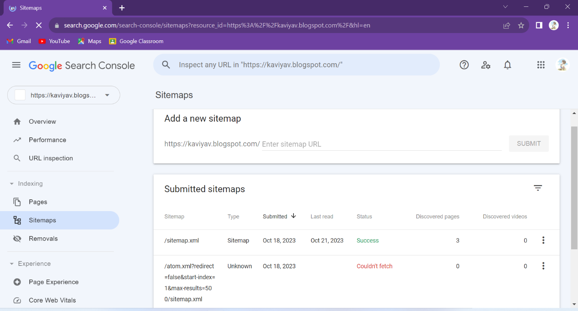V . Kaviya – 613020104036

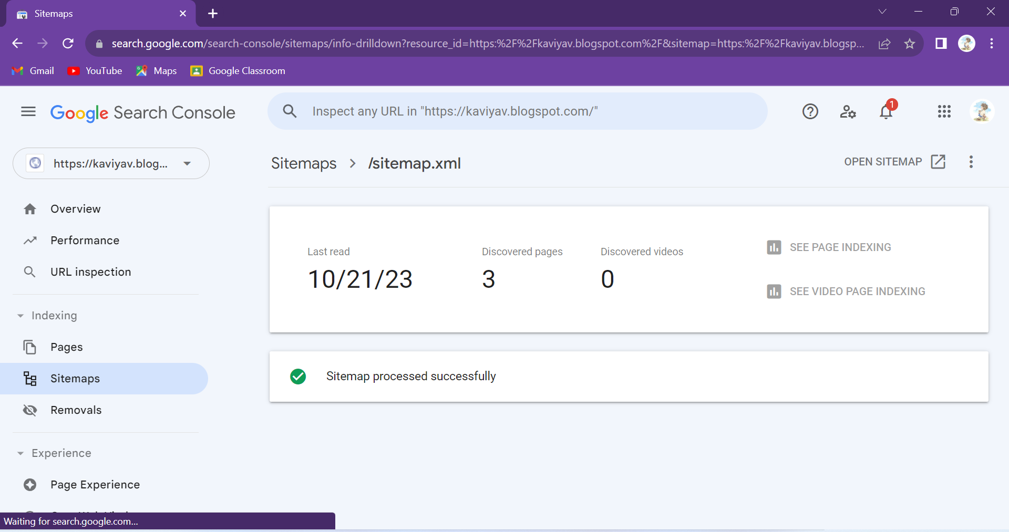

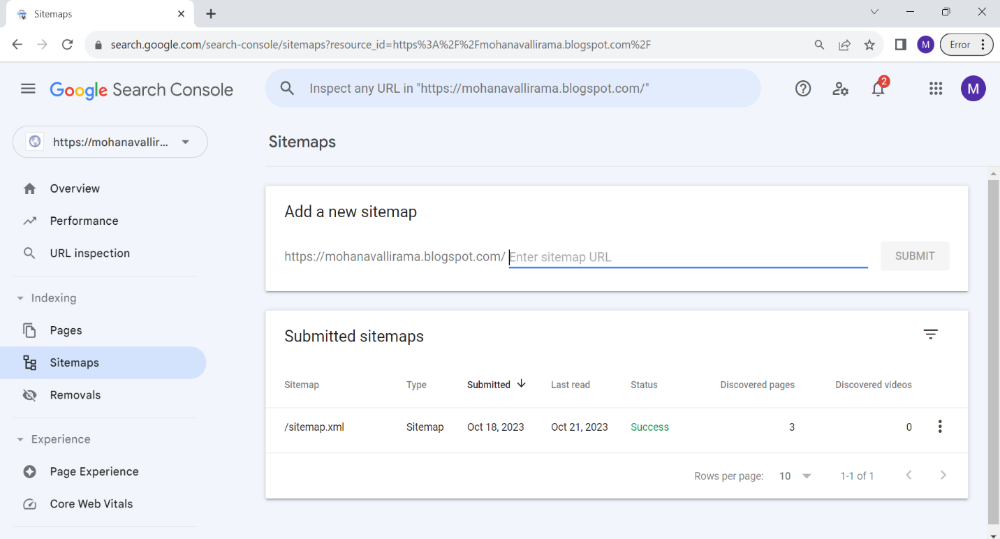M. Mohanavalli - 613020104044

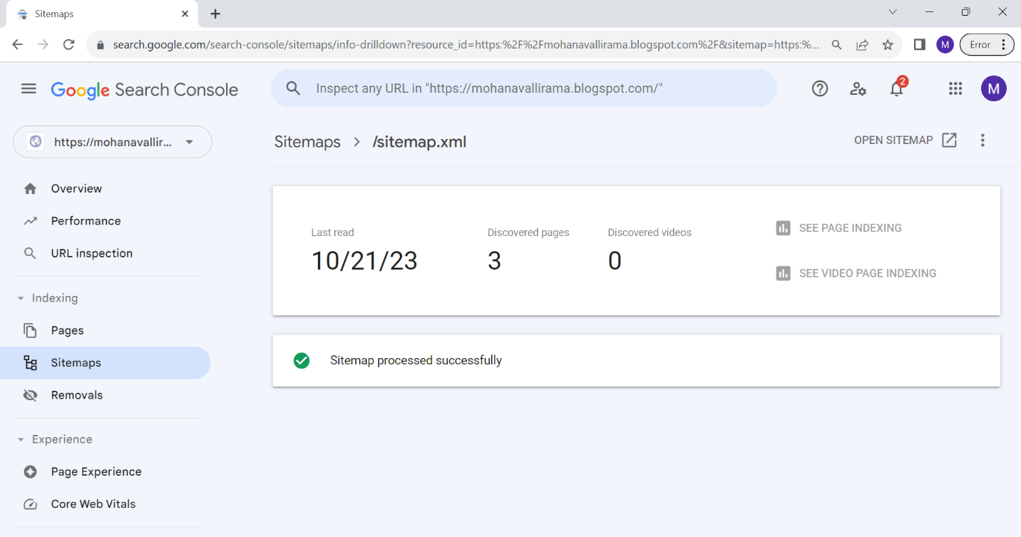

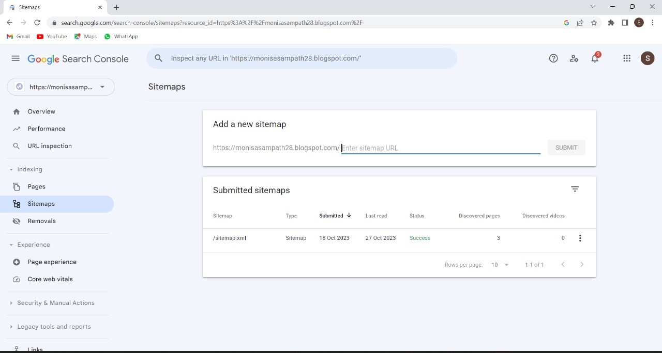S. Monisa – 613020104045

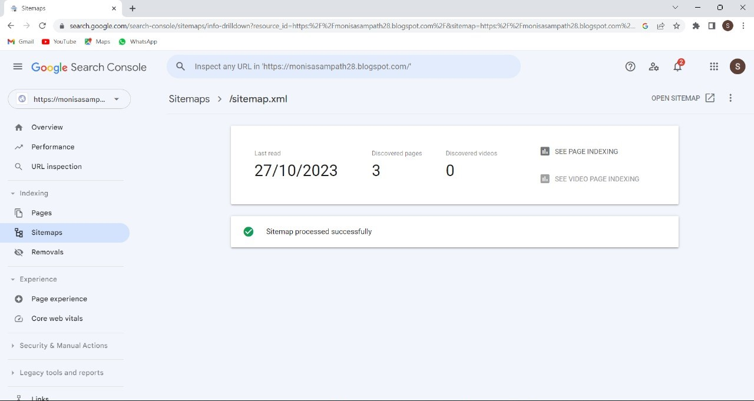

**Attachment of the video:**



**Video Link:**

<https://drive.google.com/file/d/1hcHoeYzEpFYastDud9nFEUuPXGJL1nbI/view?usp=drivesdk>